Section 5:
Post-collapse investigations

5.1 Post-collapse examinations of building debris

5.1.1 Introduction

Despite the state of the CTV building after it collapsed, the arrangement and condition of the debris provided important insights about how the building failed. Fortunately, a great deal of evidence was available to the Royal Commission, largely due to the initiative and efforts of three engineers who were part of the Urban Search and Rescue (USAR) effort.

Mr Graham Frost is Chief Engineer at Fletcher Construction Company with over 30 years of design and construction experience. Mr John Trowsdale is a chartered professional engineer and Project Director for Holmes Consulting Group with seven years’ experience as a consulting engineer. Mr Frost and Mr Trowsdale were members of the New Zealand USAR team. Dr Robert Heywood is a forensic engineer living in Australia. He has 38 years of structural engineering experience in design, field testing, failure investigation, research and education. He is part of the Queensland USAR team that came to Christchurch to assist after the earthquake. All three provided valuable evidence to the Royal Commission.

The primary objective of USAR officers immediately after the collapse was the rescue and recovery of people trapped in the building. Mr Frost, Mr Trowsdale and Dr Heywood assisted with this effort by identifying risks to New Zealand Police and USAR team members at the site. However, they realised that evidence about the state of the building would be important in identifying why it collapsed and decided to gather information. They made sketches and notes, took photographs and marked and retained around 30 samples of structural elements. Dr Heywood did not know of any standard or best-practice for the retention of samples and explained that they did the best they could in the circumstances.
The 30 samples were left with New Zealand Police and Dr Heywood had no further involvement with them. Debris from the CTV building was taken to a secure site at the Burwood landfill. Mr Frost and Dr Heywood visited this site on 28 June 2012 after they had given their initial evidence to the Royal Commission and subsequently they provided further evidence.

5.1.2 Location of debris after the collapse Mr Trowsdale arrived at the site at around 7.30pm on 22 February. Mr Frost arrived on the evening of 23 February, about 30 hours after the building
collapsed. The original structural form was not clearly discernible to him (see Figure 58(a)), however he identified the main seismic resisting elements as the wall complex to the north which was still standing and the south shear wall at the southern end of the site.

Dr Heywood started working on the CTV building
site at 4:00am on 24 February 2011. Figure 58(b) is a photograph of the building taken by him at this time. Substantial quantities of material, particularly on the eastern side, had been shifted or removed before Dr Heywood’s arrival. This consisted of the spandrels and edge beams that spilled out on to the cars parked on Madras Street, as shown in Figure 58(a). Dr Heywood explained that the building had fallen mainly within its own footprint and only the north wall complex remained standing. Remnants of floor slabs leant against the north wall complex and the south shear wall had fallen inwards on top of the debris. The external steel staircase attached to the side of the south shear wall can be used to identify its location in the debris (see Figure 58(b)). The south shear wall lay horizontally with the top section sloping down relative to the rest of the wall.

(a) Immediately following collapse (source: Graham Frost)

North wall complex

South shear wall with stairs attached

Relocated debris

(b) North wall complex and collapsed south shear wall with relocated material in the foreground at 4am on 24 February 2011 (source: Robert Heywood)

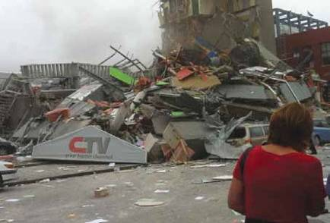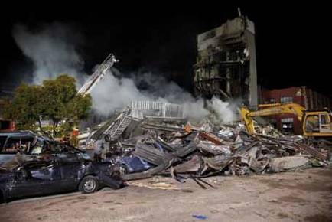Figure 58: View of debris from the corner of Cashel and Madras streets looking north-west

There was little debris south of the base of the south shear wall. This indicated that the southern half of the building had collapsed vertically with little horizontal displacement. All six levels had compressed into a pile of rubble approximately 3.7 metres high, as shown in Figure 59(a), which was equivalent to the height of
level 1 prior to the earthquake. Figure 59(b) identifies some edge beams that detached from the south shear wall. Dr Heywood explained that not all edge beams detached, with some edge beams from
level 5 and/or 6 transported northwards with the south shear wall when it fell. He also described the steel roof material being concertinaed up against the base of the north wall complex. Mr Frost said the roof had been folded in two back over the northern half of the building and was trapped under the top section of the south shear wall (see Figure 59). This observation suggested to him that the central section of the roof fell before the south wall was pulled over on top of it.

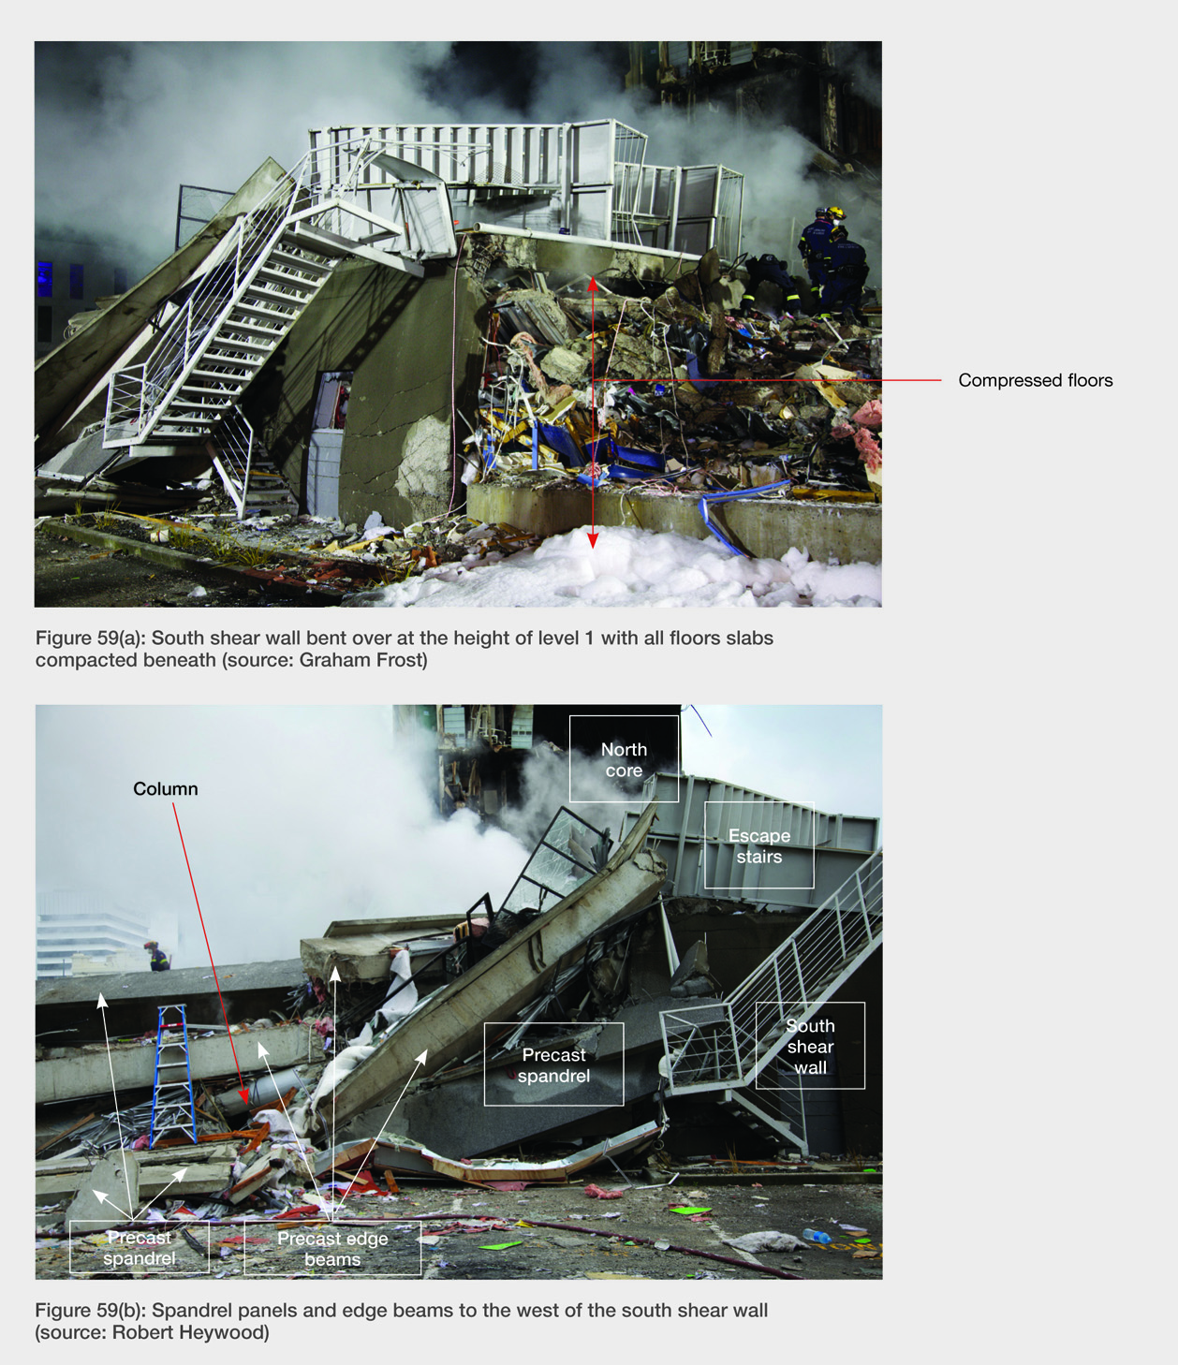

Underside of roof material which is folded to the north

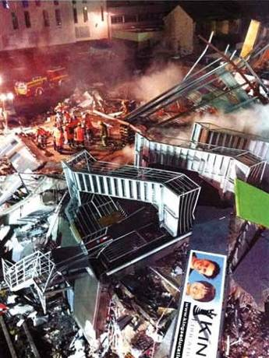Figure 59(c): View of debris from a New Zealand Fire Service snorkel basket (source: John Trowsdale)

Figure 59: Southern elevations of the collapse debris

Mr Frost said that some slabs and beams in the northern half of the building had moved several metres to the north relative to their original position. The debris to the north-east and north-west of the north wall complex had spilled out northwards, as shown in Figure 60(a) and (b). He stated that the slabs, beams and spandrel panels in the northern half of the building had been thrown northwards due to a “pendulum effect”. He considered this was caused by a combination of support being lost near the centre of the building and the building elements remaining attached to the north wall complex. As the building elements swung down they detached and were thrown northwards.

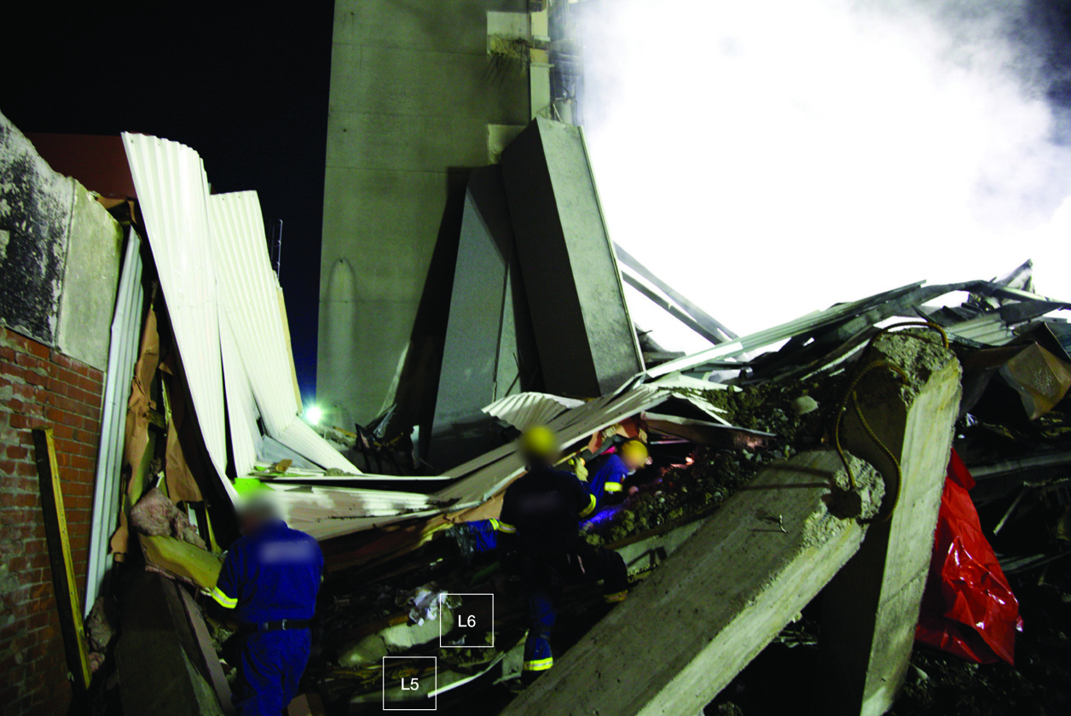

(a) North-west corner of the building looking east (source: Robert Heywood)

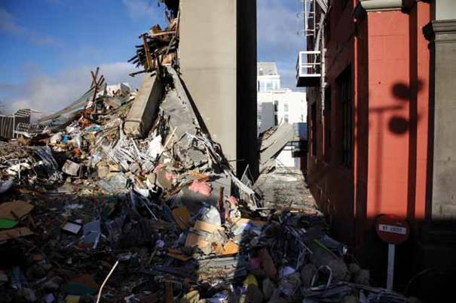

(b) North-east corner of the building looking west (source: Robert Heywood)

Figure 60: Debris located north of north wall complex

Dr Heywood described debris on the western side of the building being more defined than other sides (see Figure 61(b)). Most floor slabs lay with their ends vertically above each other, although not all slabs fell directly on top of each other. Most of the block wall had been removed before Dr Heywood arrived at the site with only a single section partially upright, as can be seen in Figure 61(a). The ends of the internal floor beams are circled in Figure 61(b). These are approximately in a vertical plane but have some relative displacement in the north-south direction. The 90º bent bars protruding from the beam ends have pulled out of the rectangular columns.

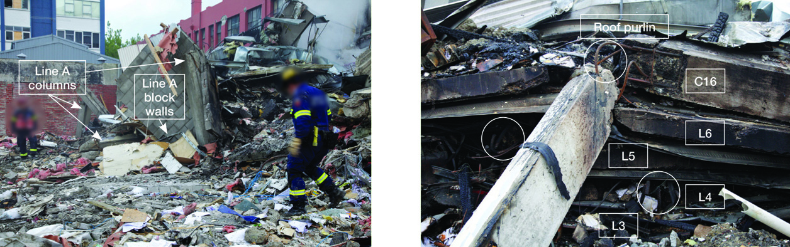

(a) Columns and block wall on the western side
(source: Robert Heywood)
(b) Collapsed slab and beam ends at the end of line 3 (source: Robert Heywood)

Figure 61: Western elevation of building

5.1.3 Observations of structural elements

5.1.3.1 Columns

Mr Frost gave evidence that the only real damage
that he saw to columns was at their ends. The central sections of the columns he saw were largely intact. Figure 62(b) shows where a precast spandrel panel adjoined a column. The unpainted area on the left of the column was covered by the spandrel panel. There was no damage to this column at the level adjacent to the top of the spandrel and Mr Frost saw no evidence of column hinging caused by spandrel panel interaction. Figure 62(c) shows the vertical and spiral reinforcement within a typical column.

Mr Trowsdale said that the columns were a mess and “lying all over the place”, and it was hard to determine whether the columns were intact at the middle or end. Beams had disconnected from the columns but he could not determine whether they had disconnected from the top or the bottom of the column.

Dr Heywood said that the west, south and east perimeter, including the exterior columns of the
building, had been substantially altered before he arrived. The circular columns on the eastern side had been removed before he arrived, although he saw and photographed segments of the circular column C2 (see Figure 59(b)).

Dr Heywood referred to photographs from the Hyland/ Smith report (see Figures 62(d) and (e)) which show the column on the south-west corner visible. A part of column C4 (about one storey in length) (see the column location diagram in Figure 62(a)) remained vertical after the collapse although concrete was missing at its base. The rectangular columns on the western elevation were detached from the building as continuous lengths but the concrete in the vicinity of the beam-column joints had been lost. The segments of columns between the floors appeared to be sound with the segments connected by the column reinforcement.

Dr Heywood said that column C19 (see Figure 62(a)) collapsed against the brick wall of the adjacent undercover car park (see Figure 62(f)). He said that this column appeared to have moved with the collapsing edge beams. The ends of the edge beams attached

to C19 came to rest near the base of the north wall complex at one end and on top of the roof of an adjacent building at the other end. He also described two storey-long segments of column C18 which remained intact and joined by column reinforcement (see Figure 62(g)). Column C18 was unique since it connected to the top of the north wall complex. This meant it could continue to support some loads even if the columns below it had gone.

Dr Heywood said that a number of interior columns above level 6 remained intact, with some maintaining their connection with the level 6 floor slab and interior beams. However, below level 6 his overall impression was that interior columns were largely reduced to reinforcement and rubble with the occasional short length of column (see Figure 62(h)).

N

C19
5

C18

4 C18
C20
C19
C23

C17
C22

C21

3
C16

C15 C14 C13

C12

C11

2 C10

C9 C8 C7

C6 C5

C4

1 C4 C3 C2 C1

A B C D E F

Figure 62(a): Plan of the building showing column locations

Paint line at the top
of where the spandrel panel abutted

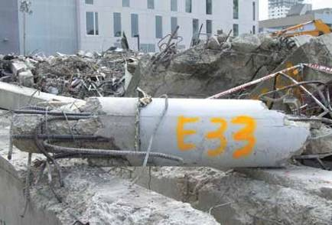Figure 62(b): Exterior column (source: Graham Frost)

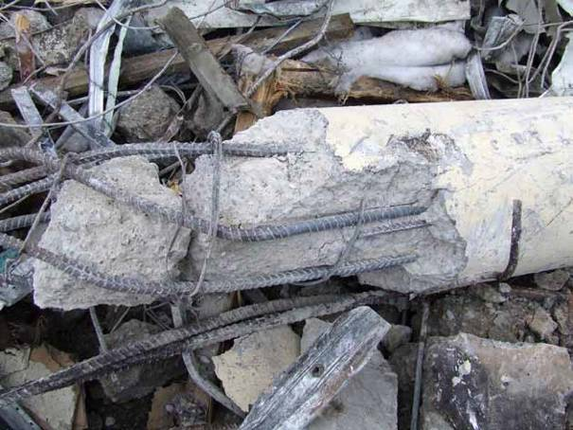

Figure 62(c): Column of unknown location showing vertical reinforcing bars and spiral transverse reinforcement. Concrete has spalled off from outside the reinforcement and fractured inside (source: Graham Frost)

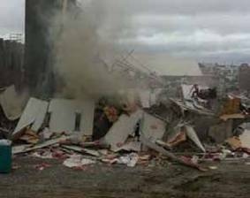Rectangular column on the south-west corner

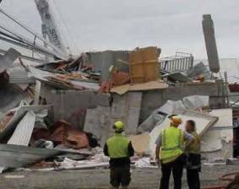Figures 62(d) and (e): The western elevation with the column on the south-west corner visible
(source: Hyland/Smith1 report)

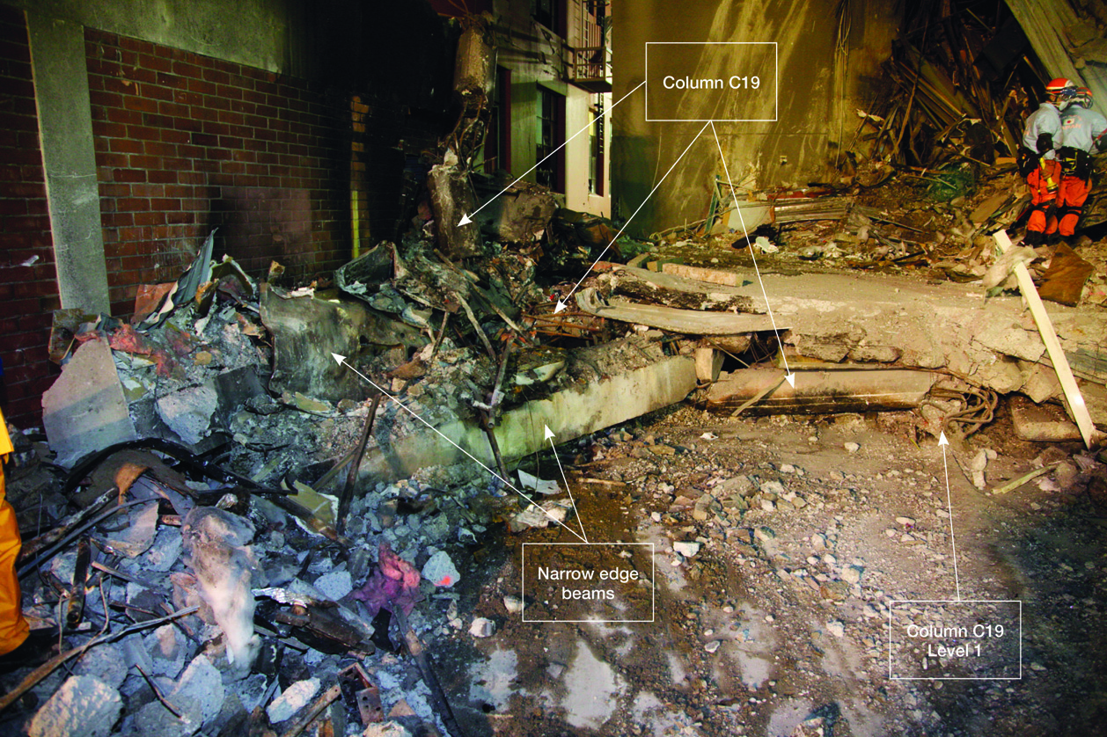

Figure 62(f): View of the north-west corner looking towards the north wall complex (source: Robert Heywood)

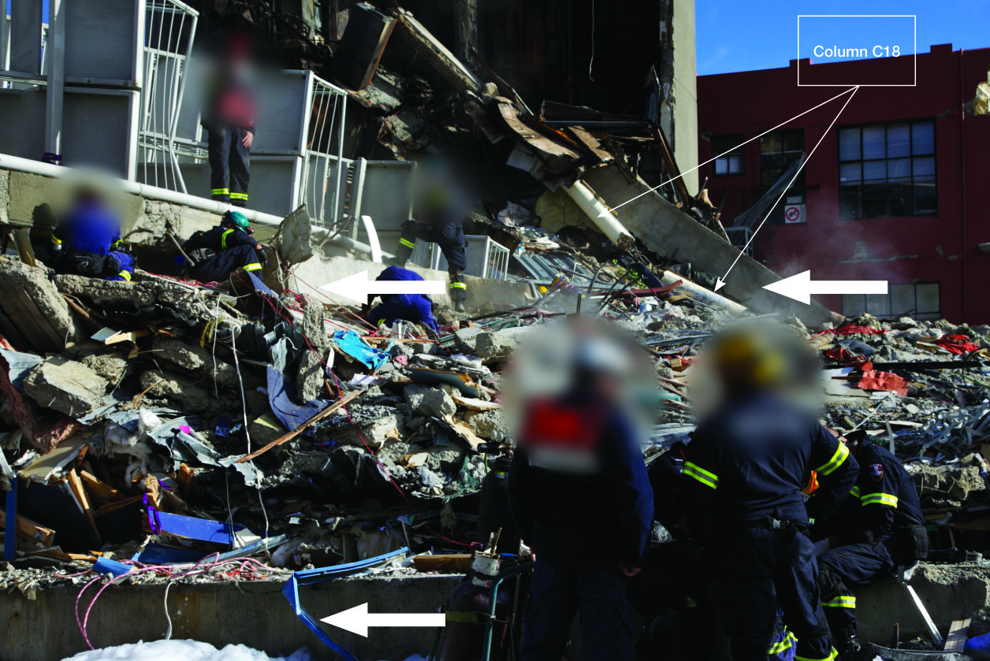

Figure 62(g): View towards the north wall complex from the south-east showing two storey-long segments of column C18 (source: Robert Heywood)

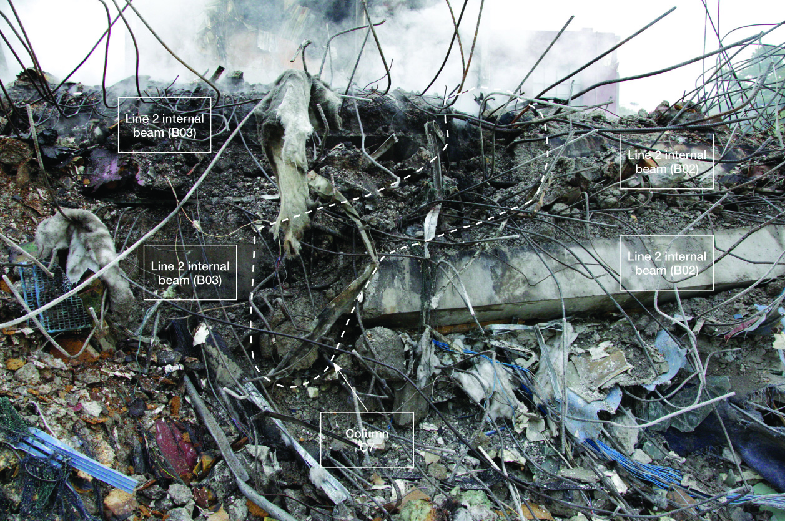

Figure 62(h): The junction between line 2 and column C7 looking north towards the north wall complex. The remains of column C7 are in the centre (source: Robert Heywood)

